**Bangladesh University of Business & Technology**

**(BUBT)**



**Project On**

**Car Game**

**Submitted By**

**Group-Shadow**

**Rayhan Al Shorif**

**Id: 16172103133**

Intake: **35th**

Program: B.Sc. Engg. in **CSE**

**Submitted To**

**Shamim Ahmed (SAM)**

Assistant Professor

Department of **CSE**

Bangladesh University of Business & Technology (BUBT)

Date of Submission: 13.01.2018

**-: Report: -**

**Project name:** Car Game.

**Project Summary:**

Project CAR which stands for Community assisted running simulator related game that’s will made for running and avoid others car. This project car is intended to represent a 2d driving simulation. It will be playing by Microsoft Windows in ***Code: Blocks*** with Graphics.

**Using Software:**

We use *Code: Blocks software for playing and developing this car game.*

**Using Header File:**

#include <graphics.h>

#include <stdlib.h>

#include <stdio.h>

#include <conio.h>

#include<DOS.h>

#include "number.h"

**Project Development Steps:**

**Step 1: Include intro**

At first, we make an intro for this game like…………………

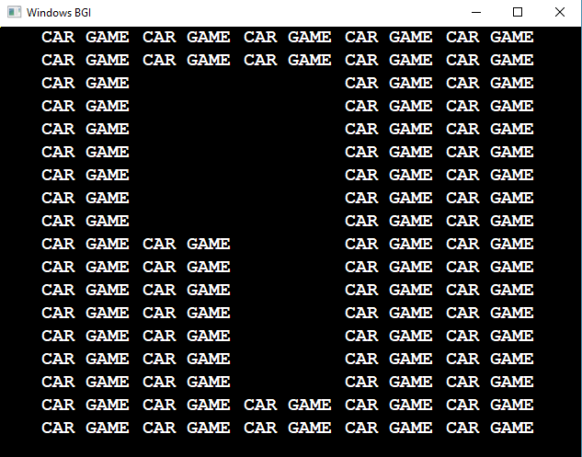

**Step 2: Start Game**

After finishing intro the gamer will see a massage ,

“Start

Press Any key to Start The Game…”

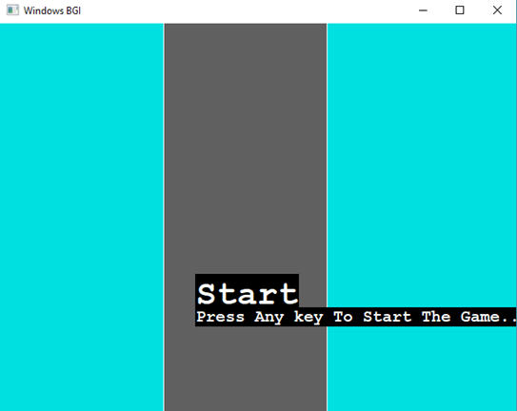

After pressing any key the game will start…But after Loading step….

**Step 3: Loading**

When the gamer will see a massage

**“**Start

Press Any key to Start the Game…”

Then the gamer press any key and the game is loading like………

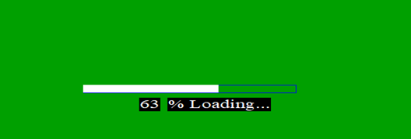

After loading the game will be starting….

**Step 4: Road Line**

In the second step we make a road and road side style with main car like……….

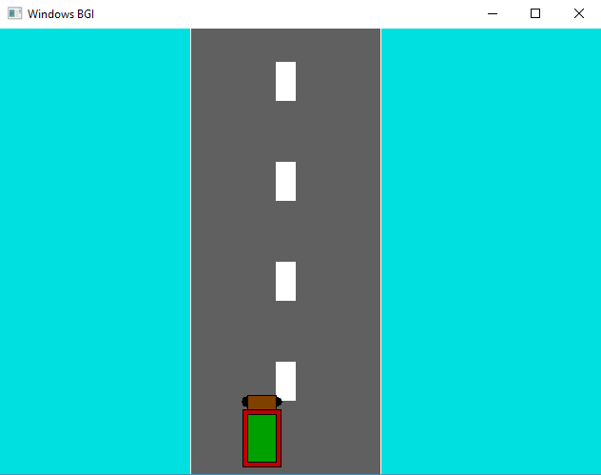

**Step 5: Point & life**

Make Point and life parts …....

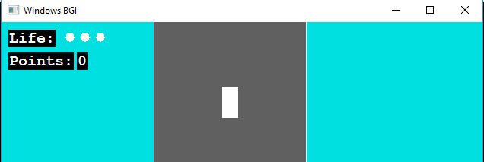

**Step 6: Main car Move**

In this step we setup the main car left and right sides moving by these keywords…….

**GetAsyncKeyState** (VK_LEFT) [ *For Moving left side*]

**GetAsyncKeyState** (VK_RIGHT) [ *For Moving right side*]\

For this keywords ,Car Moving left and right side by using Arrow Key.

**Step 7: Opponent car & Point count**

We make some opponent cars and setup point counting logics and moving all cars …Like……….

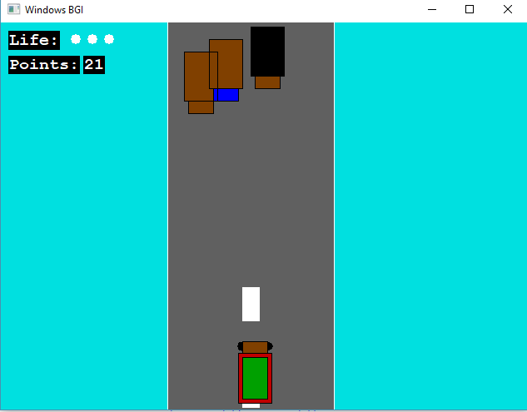

Moving car…………….

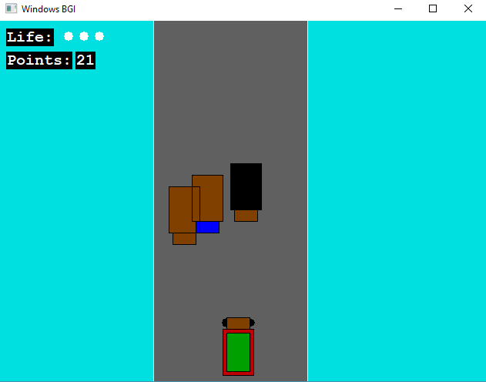

**Step 8: Using “NUMBER.h” Header file**

In development **Step 5,** when we setup the point counting logics, we also use a header file for converting our gaming code. This header file name is “number.h”.

**“number.h” header file details:**

Mainly this header file has a function. This name is “Pointnumber()”. We pass three parameters by this function. That are

* Count number.
* X axis.
* Y axis.

After counting number or point, we show it in this header file. Any programmer using this header file for counting or showing count number in any program.

**Step 9: Level Up**

When the gamer makes 10 points or more, he achieves Level Up. The game level up and cars pass faster than before. In this step we use “DOS.h” header file and use “delay ()” keyword.

**Step 10:** **Sound System**

There is a sound system to attract the gamer’s mind in the game.

We used beef sound in this project.

**Step 11:Crash**

If main car will crash by opponent cars, a massage will see in font of the game screen in “Crash 1” “Crash 2” “Crash 3”. It will show three Crash function.

* Crash1()
* Crash2()
* Crash3()

**Step 12:** **Extra Life**

There are a extra life step. At first, a gamer get three life but he gets a extra life if he gets. But if the gamer has achieve fore lifes, he show a massage on display. This massage is “Life is Full , Don’t Touch”…. like……….

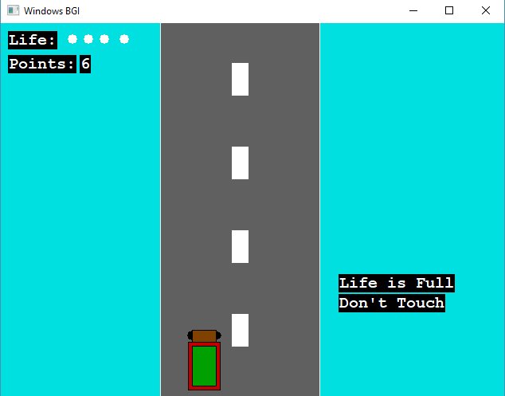

Extra point is a white circle……. like………

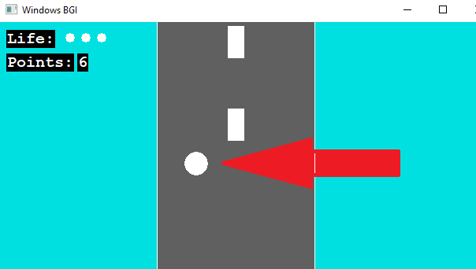

**Step 13:** **End**

When the game will end, then call an end function where showing

“GAME OVER” 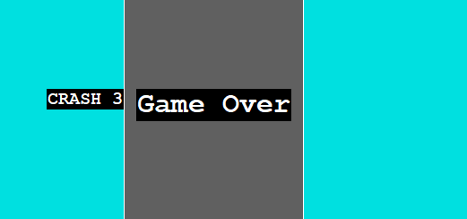

**Style of Scenery: -**

* + Simple Road.

**Project Function:**

Function Keyword:

* Integer Main ()
* Arrow key ()
* Sound ()
* Crash1()
* Crash2()
* Crash3()
* End ()

**Project Conclusion:**

Our Goal is to Run skill development of this game. Making this game more attractive for gamer and make more faxable for gamer. Using adding more graphics work and this games field like a real-world part. We this game will be easy for playing game. This is a simple but extra ordinary game project. This game is for all classes of people. This is a cost-free game. Anybody can play this and enjoy this game’s environment.